# INTRODUCTION

* 1. Overview

The project aim is to provide real-time knowledge for all the students who have basic knowledge of Salesforce and Looking for a real-time project. This project will also help to those professionals who are in cross-technology and wanted to switch to Salesforce with the help of this project they will gain knowledge and can include into their resume as well.

A brief description about ours project

* 1. A travel approval app is a system or application that is used to manage and track the process of approving and booking business travel. It might be used by a company to streamline the process of approving and booking travel for employees, and to track and manage the details of those trips.
  2. Purpose

This Project helps in sending your travel approval requests to your manager in place of emails.

The use of this project. What can be achieved using this.

* Travel approval means **approval of official travel in advance by an appropriately delegated officer, utilizing the appropriate form or system**.
* Travel request forms are designed **to give management an overview of the intended business trip from both a cost and a strategic point of view**.
* It can **help sort out any issues during check-in at the airport or hotel**
* Proof of confirmed travel plans can be **plane ticket confirmation, business letter, or employment letter from the business HR Department**.
* Travel Approval Request App will **help users quickly send a "Travel Request" through mobile using Power Apps**.

1. **Problem Definition & Design Thinking**
   1. Empathy Map

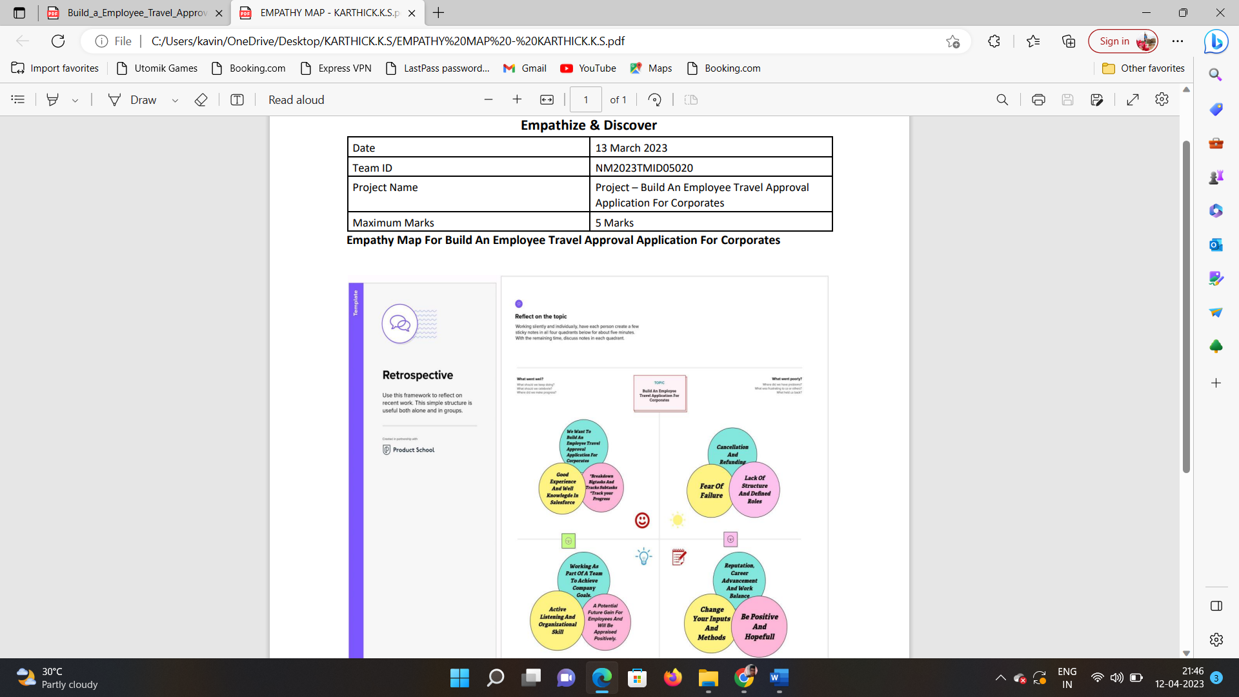

* 1. Ideation & Brainstorming Map

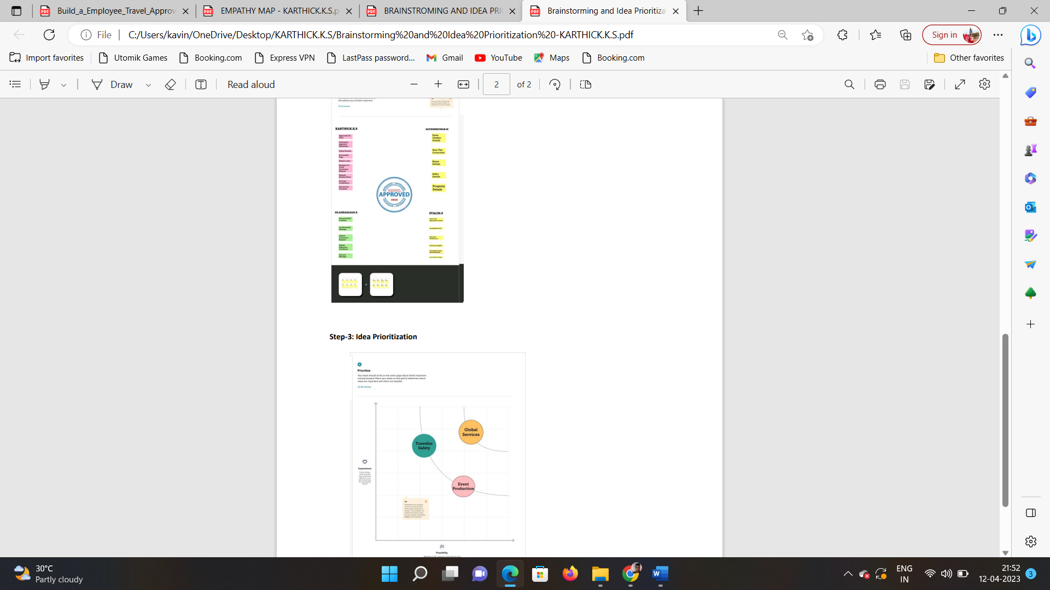

# RESULT

* 1. Data Model:

|  |  |
| --- | --- |
| Field label | Data type |
| City | Text |
| Phone number | Number |

|  |  |
| --- | --- |
| **Object name** | **Fields in the Object** |
| Obj1  Department | |  |  | | --- | --- | | Field label | Data type | | Department Name | Text | |
| Obj 3  Travel Approval | |  |  | | --- | --- | | Field label | Data type | | Travel Approval Name | Text | |
| Obj 4  Expense Items |  |

## Activity & Screenshot

|  |  |
| --- | --- |
| Field label | Data type |
| Expense Items Name | Text |

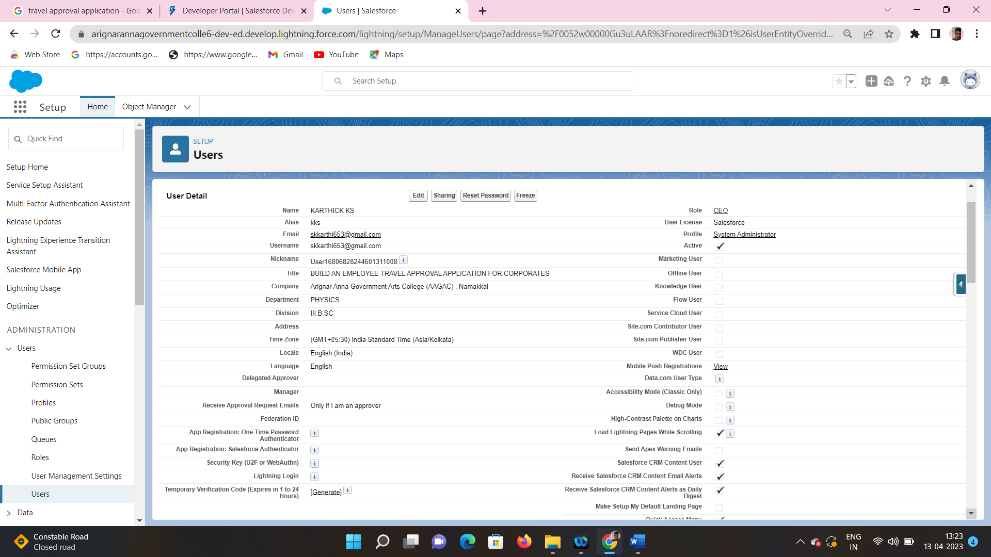

## 

## Trailhead Profile Public URL

**Team Lead –** [**https://trailblazer.me/id/kkarthick19**](https://trailblazer.me/id/kkarthick19)

**Team Member 1 -** [**https://trailblazer.me/id/sathish0143**](https://trailblazer.me/id/sathish0143)

**Team Member 2 -** [**https://trailblazer.me/id/rsilambarasan**](https://trailblazer.me/id/rsilambarasan)

**Team Member 3 –**

[**https://trailblazer.me/id/stalin**](https://trailblazer.me/id/stalin)

# ADVANTAGES & DISADVANTAGE

List of advantages

* Approval automation **promotes accountability and transparency** and the need for micromanagement is reduced as managers are at ease with delegating ownership of tasks.
* Automated approval workflows can **eliminate bottlenecks in the process, boost efficiency and improve workplace productivity**.

List of disadvantages

* Assuming always-on data connection. It's not always on.
* Requesting too many permissions.

# APPLICATIONS

* It can help sort out any issues during check in at the airport or hotel.
* App will helps users to quickly send an “TRAVEL REQUEST”.

1. CONCLUSION

This Project helps in sending your travel approval requests to ours Manager in place of emails.

# FUTURE SCOPE

It has endless job opportunities in India as large number of heritage, cultural and other tourists throng the country every year.